**SDLC phase 1: PLANNING**

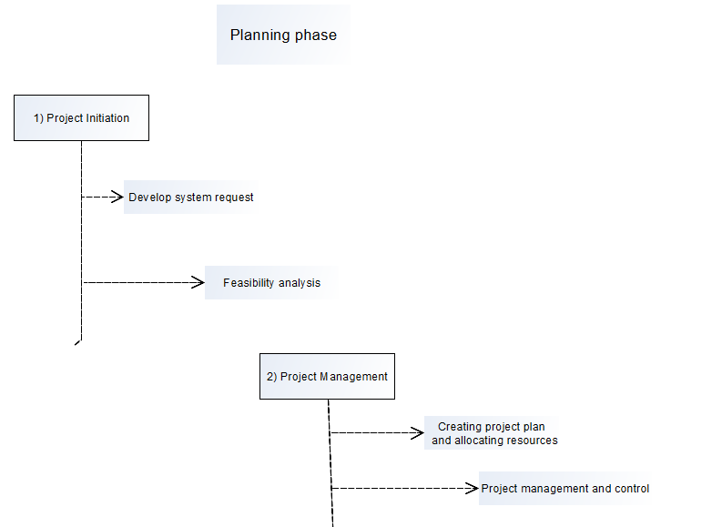

The planning phase is divided into two steps.

1. Project Initiation:

This is the very first step of system development. We discuss this step by dividing it into two sub-steps: *Developing system request and Feasibility analysis.*

1. A system request presents a brief summary of a business need, and it explains how a system that supports the need will create business value. Most ideas for new systems come from outside the IS area (from the marketing department, accounting department etc.) in the form of a system request.
2. The IS department works together with the person or department generating the request (called the project sponsor) to conduct

a feasibility analysis. The feasibility analysis examines key aspects of the proposed project:

■ The technical feasibility (Can we build it?)

■ The economic feasibility (Will it provide business value?)

■ The organizational feasibility (If we build it, will it be used?)

1. Project Management:

Once the project is approved, it enters project management. During project management, the project manager creates a work plan, allocates resources necessary for the project and staffs the project, puts techniques in place to help the project team control and direct the project through the entire SDLC. The deliverable for project management is a project plan that describes how the project team will go about developing the system.

The brief description of **planning phase** is given above. Now we will discuss the details of **“Feasibility analysis”**.

**FEASIBILITY ANALYSIS**

* Feasibility analysis guides the organization in determining whether to proceed with the project. Feasibility analysis also identifies the important risks associated with the project that must be managed if the project is approved.
* As with the system request, each organization has its own process and format for the feasibility analysis, but most include techniques to assess three areas: technical feasibility, economic feasibility, and organizational feasibility (see Figure 1-7). The results of evaluating these three feasibility factors are combined into a feasibility study deliverable that is submitted to the approval committee at the end of project initiation.

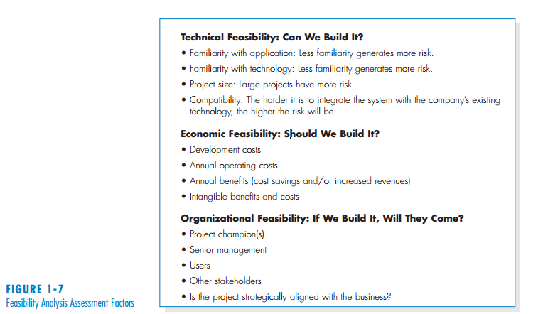

1. Technical Feasibility: For details description, see: **System Analysis and Design (5th edition): chapter 1.**
2. Economic Feasibility:

* Economic feasibility is determined by identifying costs and benefits associated with the system, assigning values to them, calculating future cash flows, and measuring the financial worthiness of the project.
* Organizations have limited capital resources and multiple projects will be competing for funding, so it is important to analyze the economic feasibility before starting a new project.
* We will discuss two different methods for economic feasibility analysis: Simple Cash Flow Method and discounted cash flow method.

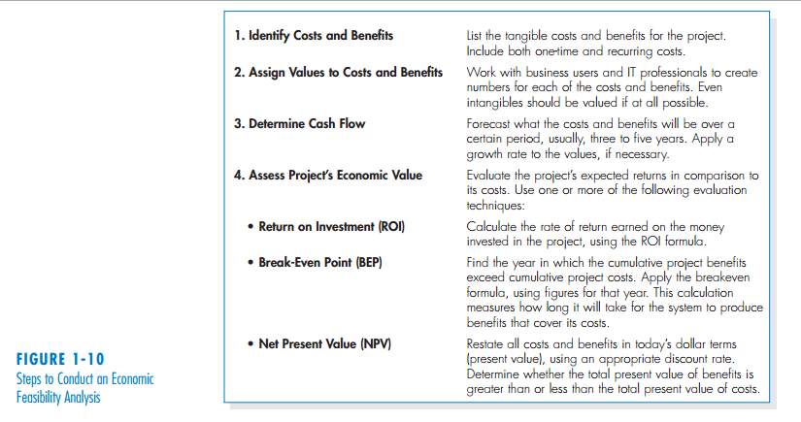

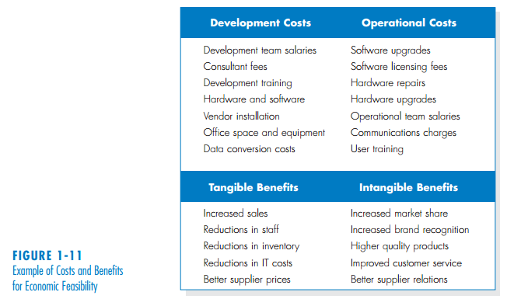

Once the costs and benefits are identified and monetary values are assigned, we need to determine the cash flow. Now what is **Cash Flow**?

* A formal cost–benefit analysis usually contains costs and benefits over a selected number of years (usually, three to five years) to show cash flow over time. In simple words, we predict or forecast the costs and benefits for next several years and project the flow of cash over time- this is called cash flow.

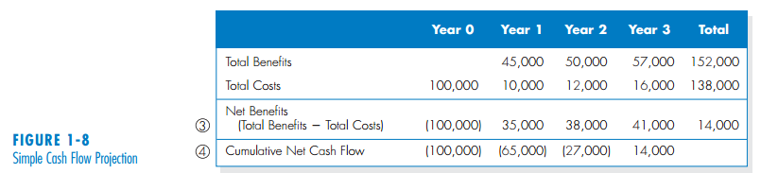

**ROI, BEP, NPV:**

C:\Users\Guest Faculty\Desktop\r.PNG

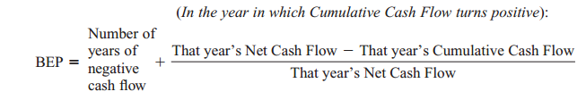

C:\Users\Guest Faculty\Desktop\np.PNG

We need to calculate the NPV to determine if a project is economically feasible or not. As long as the NPV is greater than zero, the project is considered economically acceptable.

**What are the disadvantages of Simple Cash Flow method and how to overcome it?**

Simple cash flow method does not recognize the time value of money. In these method, the timing of cash flows is ignored. A dollar in Year 3 of the project is considered to be exactly equivalent to a dollar received in Year 1.

Another method namely “Discounted cash flow method” eliminates this problem by using the concept of “rate of return”. It uses the following formula to calculate the present value of money.

C:\Users\Guest Faculty\Desktop\pv.PNG

By the above formula, $100 received in 3 years with a required rate of return of 10% has a PV of $75.13.

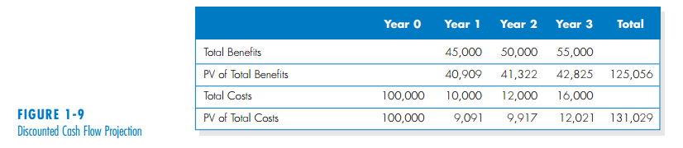

Math example:

